Case Study 5: Attendance Recovery

1. Problem Statement
Calculate current attendance percentage and find how many consecutive classes a student must attend to reach a target percentage.

2. Objectives
- Calculate current attendance percentage.
- Find additional classes needed.

3. Assumptions
- Total classes must be greater than zero.
- The student attends all additional classes.

4. Algorithm
1. Read total classes, attended classes, and target percentage.
2. Calculate current percentage.
3. Use a while loop to count future classes until the target is reached.
4. Display results.

5. Flowchart
START → Input class counts and target → Calculate percentage → Repeat future class count until target reached → Display → STOP
For a drawn flowchart, use: oval for START/STOP, parallelogram for input/output, rectangle for calculations, and diamond for decisions.

6. Pseudocode
READ total, attended, target
percentage = attended / total * 100
future = 0
WHILE (attended + future) / (total + future) * 100 < target: future = future + 1
DISPLAY percentage, future

7. Python Source Code
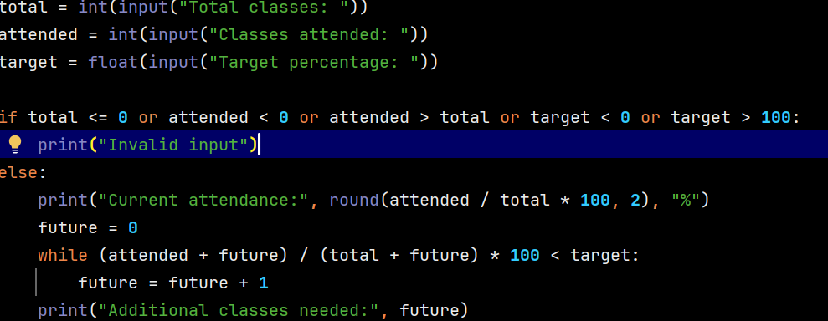

8. Test Cases
Test 1: 40 total, 30 attended, target 75 → 0 additional classes. Test 2: 40 total, 24 attended, target 75 → 24 classes.

Sample Output
Input: total 40, attended 24, target 75
Output: Current attendance: 60.0 %
Additional classes needed: 24

9. Conclusion
The program uses a while loop to find how many classes are needed to meet an attendance target.

